# Terraform Providers:

<https://www.terraform.io/docs/language/expressions/version-constraints.html>

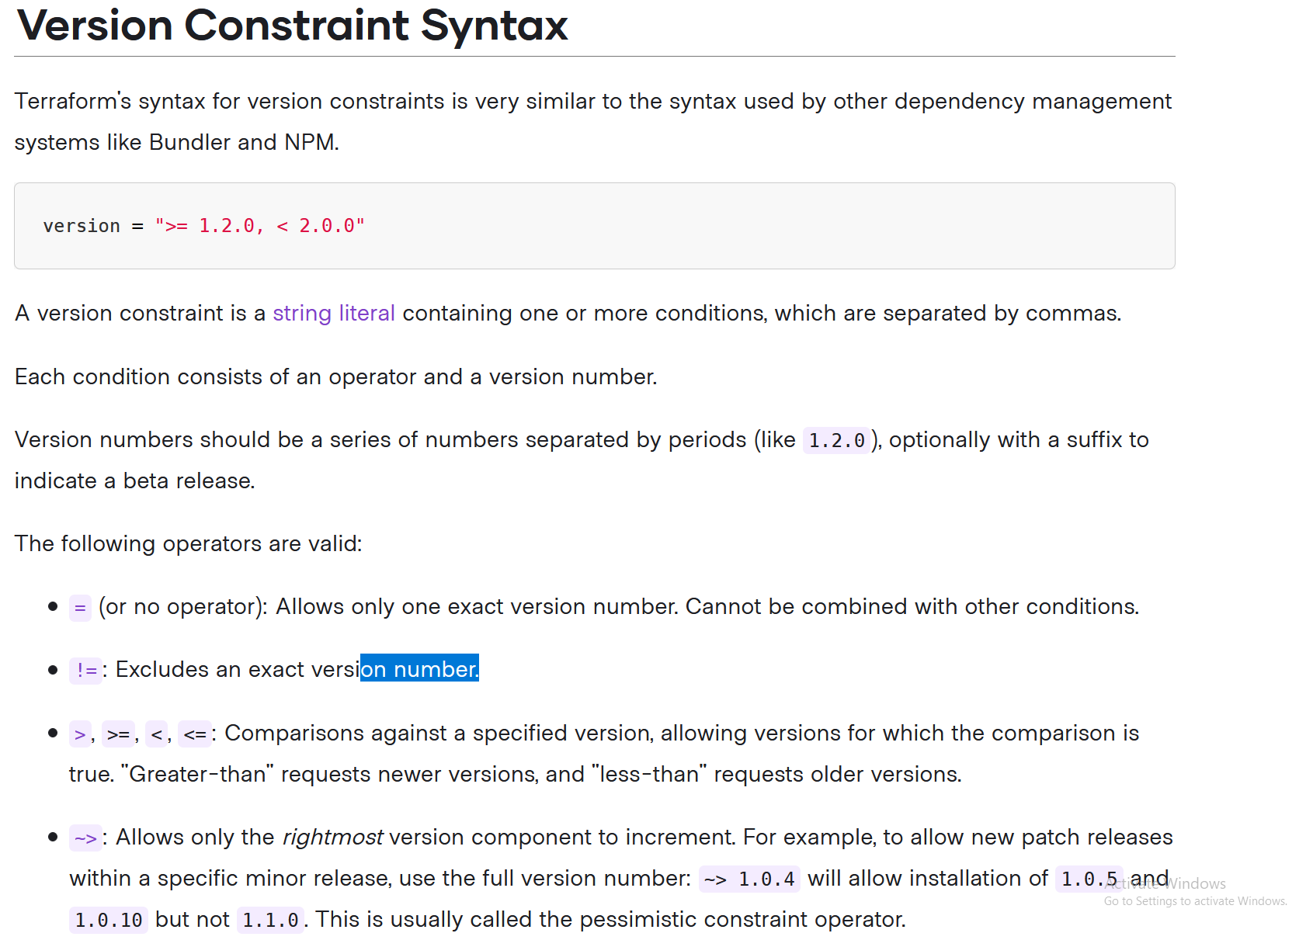

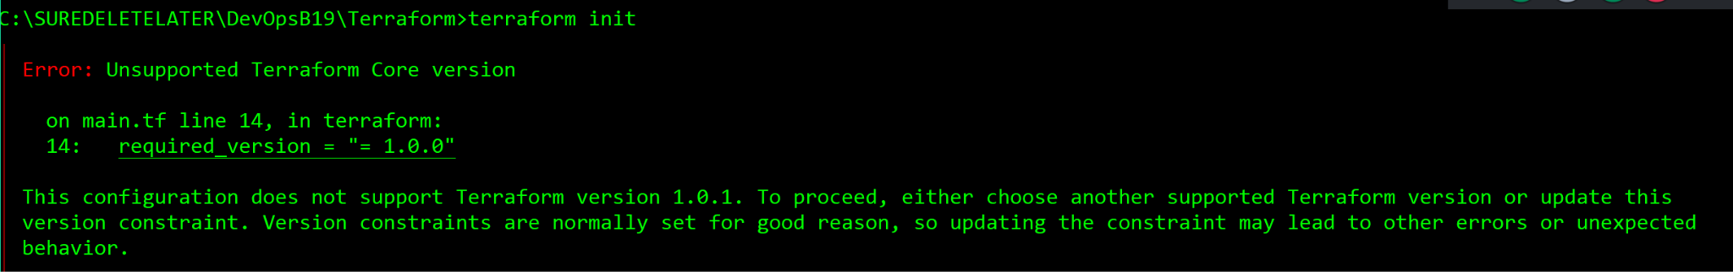

Using multiple providers like AWS & Azure:

terraform {

required_providers {

aws = {

source = "hashicorp/aws"

version = "~> 3.0"

}

azurerm = {

source = "hashicorp/azurerm"

version = "=2.46.0"

}

}

#required_version = "<= 1.0.5, >= 0.14.10"

#required_version = "~> 1.0.0"

required_version = "= 1.0.0"

}

provider "aws" {

region = "us-west-2"

access_key = "my-access-key"

secret_key = "my-secret-key"

}

provider "azurerm" {

features {}

}

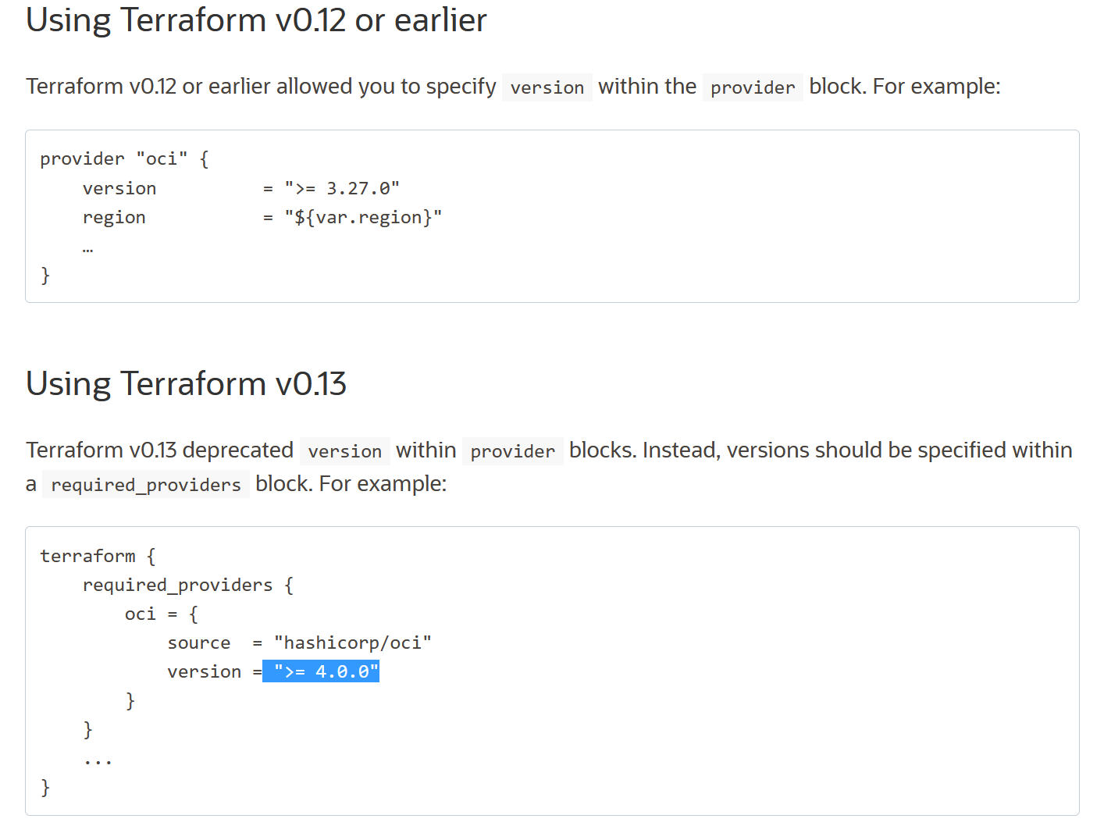

# Terraform Aliases:

<https://docs.oracle.com/en-us/iaas/Content/API/SDKDocs/terraform-targeting-multiple-regions.htm>

If you want to use more than one region within a single Terraform config, multiple providers are required. Each provider must be given an alias. For example:

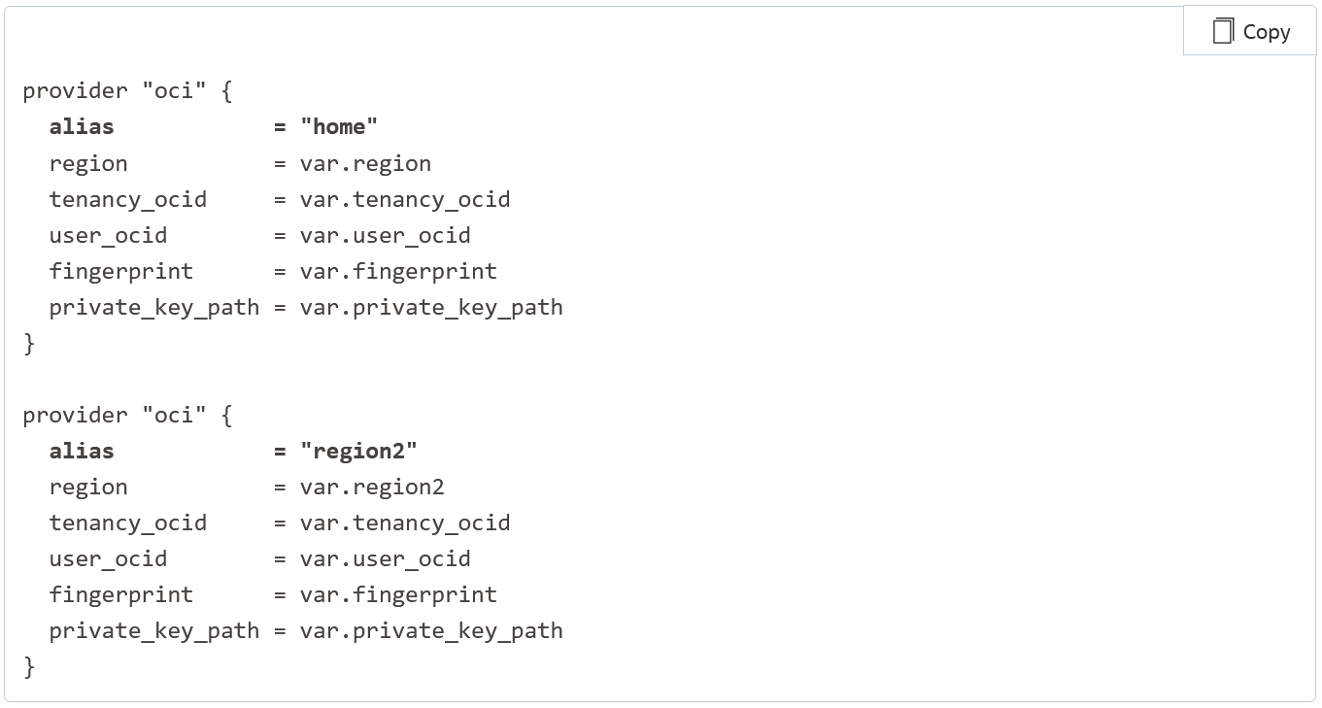

resource "aws_vpc" "testvpc1" {

cidr_block = "10.123.0.0/16"

enable_dns_hostnames = true

tags = {

Name = "aliasvpctesting"

Owner = "Sreeharsha Veerapalli"

environment = "prod"

}

}

resource "aws_vpc" "ohiotestvpc1" {

provider = "aws.us-east"

cidr_block = "10.123.0.0/16"

enable_dns_hostnames = true

tags = {

Name = "aliasvpctesting"

Owner = "Sreeharsha Veerapalli"

environment = "prod"

}

}